Experiment - 6
Student Name: Mankaran Singh Tandon UID: 23BCS10204
Branch: BE-CSE Section/Group: KRG_2B
Semester: 5th Date of Performance: 22/9/25
Subject Name: Advanced Database and Management System
Subject Code: 23CSP-333

Problem Description/Aim:
Medium-Problem Title: Gender Diversity Tracking-Create a PostgreSQL stored
procedure to track gender diversity in the workforce. The procedure takes a gender as input and returns the total number of employees of that gender, providing HR with instant and secure reporting.

Procedure (Step-by-Step):
  - Create a table employees with columns like emp_id,emp_name and gender.
  - Insert sample data with varying genders.
  - Create a stored procedure ‘count_employees_by_gender’ that:
    - Takes a gender as input.
    - Counts the number of employees with that gender.
    - Returns the result as an OUT parameter.
  - Call the procedure in a DO block to capture and display the result.

Sample Output Description:
    - Input: ‘Male’ --- Output: 3
    - Input: ‘Female’ Output: 2
-HR sees results instantly without accessing full employee data.

Hard-Problem Title: Order Placement and Inventory Management-Automate the ordering process in a retail company. The procedure validates stock availability, logs sales, updates inventory, and provides real-time confirmation or rejection messages.

Procedure (Step-by-Step):
- Create products table with columns: product_id, product_name, price, quantity_remaining, quantity_sold.
- Create sales table with columns: sale_id, product_id,

quantity, total_price, sale_date.
- Create a stored procedure place_order that:
  - Takes product_id and quantity as input.
  - Checks if quantity_remaining is sufficient.
  - If yes:
    - Logs the sale in sales table.
- Updates products(decrease quantity_remaining, increase quantity_sold).
    - Display “Product sold successfully!!”.
  - If no:
    - Display “Insufficient quantity available!!”
- Call the procedure for different orders to validate functionality.

Sample Output Description:
- Order 5 units of Smartphone (stock available): "Product sold successfully!".
- Order 100 units of Tablet (insufficient stock): "Insufficient Quantity Available!".
- Inventory updates automatically for successful orders.

- Objective: The objective is to automate critical business operations using PostgreSQL stored procedures. For HR, it tracks gender diversity by returning the total count of employees by gender. For retail, it manages orders by validating stock, logging sales, updating inventory, and providing real-time confirmation or rejection messages. This ensures efficiency, accuracy, and real-time insights in both workforce and inventory management.

SQL QUERY AND OUTPUTS -

--------------------------------------MEDIUM PROBLEM------------------------------------------
CREATE TABLE employees
( emp_id SERIAL PRIMARY KEY,
emp_name VARCHAR(100), gender VARCHAR(10)
);
-- Sample data
INSERT INTO employees (emp_name, gender) VALUES ('Amit', 'Male'),
('Priya', 'Female'),
('Ravi', 'Male'),
('Sneha', 'Female'),
('Karan', 'Male');

select * from EMPLOYEES;

----CREATING A PROCEDURE---- CREATE OR REPLACE PROCEDURE
count_employees_by_gender( IN input_gender VARCHAR, OUT total_count int
)
LANGUAGE plpgsql AS $$

BEGIN
SELECT COUNT(*) INTO total_count FROM employees
WHERE gender = input_gender; END;
$$;

---CALLING THE PROCEDURE----- DO
$$ DECLA RE
result INT; BEGIN
CALL count_employees_by_gender('Male', result);
RAISE NOTICE 'TOTAL EMPLOYEES OF GENDER Male ARE %', result; END;
$$;
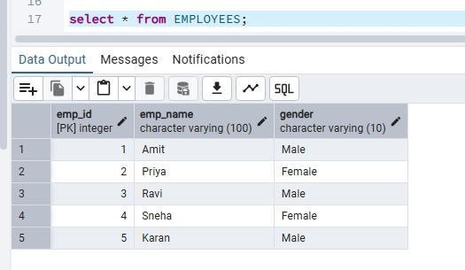

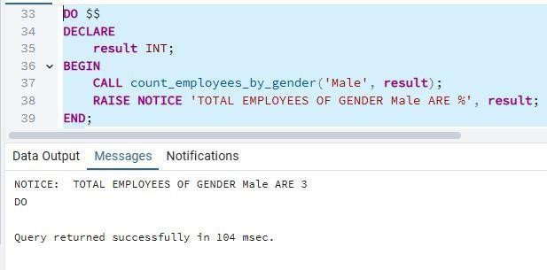

--------------------------------------HARD PROBLEM ------------------------------------------------

CREATE TABLE products (
product_id SERIAL PRIMARY KEY, product_name VARCHAR(100), price NUMERIC(10,2),
quantity_remaining INT, quantity_sold INT DEFAULT 0
);

INSERT INTO products (product_name, price, quantity_remaining) VALUES ('Smartphone', 30000, 50),
('Tablet', 20000, 30),
('Laptop', 60000, 20);
CREATE TABLE sales (
sale_id SERIAL PRIMARY KEY,
product_id INT REFERENCES products(product_id), quantity INT,
total_price NUMERIC(10,2),
sale_date TIMESTAMP DEFAULT NOW()
);

CREATE OR REPLACE PROCEDURE
place_order( IN p_product_id INT, IN p_quantity INT
)
LANGUAGE plpgsql AS $$

DECLARE
available_stock INT; product_price NUMERIC(10,2);

BEGIN
SELECT quantity_remaining, price INTO available_stock, product_price FROM products
WHERE product_id = p_product_id;
IF available_stock IS NULL THEN
RAISE NOTICE 'Product ID % does not exist!', p_product_id; ELSIF available_stock >= p_quantity THEN

-- LOGGING THE ORDER
INSERT INTO sales (product_id, quantity, total_price)
VALUES (p_product_id, p_quantity, p_quantity * product_price);
UPDATE products
SET quantity_remaining = quantity_remaining - p_quantity, quantity_sold = quantity_sold + p_quantity
WHERE product_id = p_product_id;

RAISE NOTICE 'Product sold successfully!'; ELSE
RAISE NOTICE 'Insufficient Quantity Available!'; END IF;

END;
$$;

CALL PLACE_ORDER(2,20); --PRODUCT SOLD SUCCESSFULLY AND QUANTITY_REMAINING COLUMN SET TO -20 AND DATA LOGGED TO SALES TABLE
SELECT * FROM SALES; SELECT * FROM PRODUCTS;
CALL PLACE_ORDER(3,100); --INSUFFICIENT QUANTITY AVAILABLE

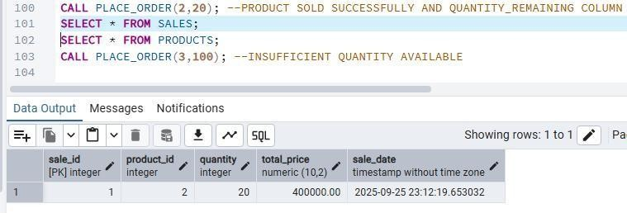

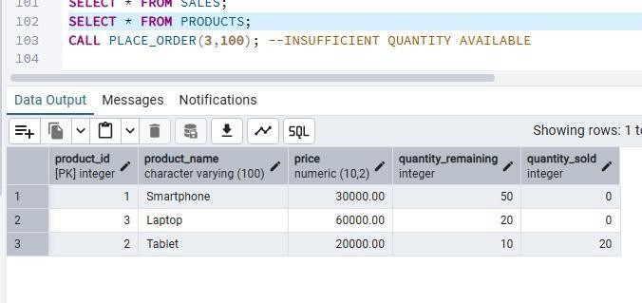
--Here in above output, After selling 20 tablets (id==2) we are left with 10 and the selling data is logged into sales table.
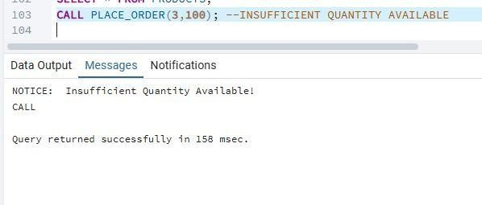
ID ==3 means laptop are 20 only and we place order for 100 …so we get notice - for insufficient quantity!!

